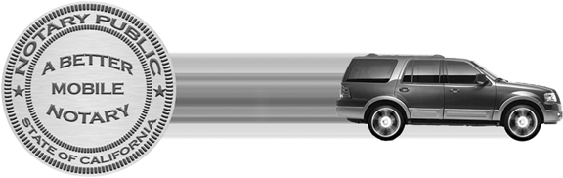
A Better Mobile Notary

SERVICE REQUEST FORM
fax to (619) 330-2843

Date of Request:

Escrow Company or Lender:

Address:

Telephone Number(s):

Contact Person:

Escrow#:

Borrower’s Name:

Borrower’s Address:

Borrower’s Telephone Number(s):

Requested Signing Date:

Requested Signing Time:

Return Documents To:

Address (if different from above):

Telephone Number (if different from above):

Courier Service:

Account Number:

Additional Comments or Requests:

